Analyzing the Effect of the Common Fisheries Policy on the UK’s Fishing Industry: Better With Brexit?

Meagan Klebanoff

ECON 490 — Honors Seminar: Special Problems in Economics

Advisor: Professor Bob Turner

May 5th 2017

*Abstract:*

This paper analyzes the economic and environmental impacts of the European Union’s Common Fisheries Policy (CFP) on the United Kingdom’s fishing industry by employing a regression discontinuity empirical design that incorporates annual data from 1950 to 2015. I find that the implementation of the CFP in 1983 led to a decrease of 198.25 £ million (in 2005 £) in the value of landings landed by the UK fleet, statistically significant at the 5 percent level. This result is robust to changes in the running variable year specification, but not particularly robust to higher functional form specifications. This is due to data limitations. In spite of this, I am confident in the general trend that my results estimate. I find that the reforms of the CFP did not have an additional substantial effect on the industry. These results support the consensus amongst UK fishermen that the CFP contributed to the decline of their industry. Additionally, I measure the effect of the policy on two important UK fish stocks: cod and haddock. I find the environmental effects of the policy to be inconclusive, predominantly due to the lag in how soon fish stocks respond to policy change and environmental factors. However, my results support the notion that, while the CFP did not increase fish stocks to previous levels, it did contribute to preventing their continual decline. I conduct additional regressions analyzing fish prices, imports, and exports in order to provide a more holistic understanding of the impact of the CFP on the UK’s fishing industry. There are many important considerations for the UK fishing industry as it approaches Brexit, and it is yet to be determined if the industry will be better off outside of the EU.

1. **Introduction**

The exploitation of fisheries, and the resulting decline of fishing industries, is a global issue. 28 percent of global fisheries are either exploited, depleted, or recovering from depletion, and an additional 52 percent are fully exploited (Walter 2010). Consequently, national and international organizations have implemented policies to regulate fisheries. One such policy is the European Union’s Common Fisheries Policy (CFP), which was adopted in 1983. The impacts of the CFP have been mixed, and many policymakers deem the policy unsuccessful. This is especially the case in the United Kingdom (UK), which has seen a decline in its fishing industry for several decades. In fact, since 1984, the UK has been a net importer of fish (Finch 2015). Once the UK officially leaves the European Union, they will no longer abide by the CFP.

My research is to determine whether or not the European Union’s Common Fisheries Policy negatively affected the United Kingdom’s fishing industry, and what the UK leaving the EU might mean for the industry. To do so, I use historical data about the UK’s fishing industry from before the policy implementation to the present day in order to analyze the economic and environmental impacts of the CFP.

This research is particularly relevant given the UK’s EU Referendum Vote on June 23rd 2016, in which the UK voted to leave the European Union. One particularly interesting aspect of the vote is the perception of UK fishermen. 92 percent of UK fishermen were in favor of leaving the EU, primarily due to their belief that the CFP caused, or at least contributed to, the decline of the UK fishing industry in recent decades (UK in a Changing Europe 2016). I test this belief through my empirical research. My research has four main objectives. First, to determine how the EU’s Common Fisheries Policy affected the UK’s fishing industry. Second, to determine whether or not the reforms to the CFP were beneficial to the UK’s fishing industry. Third, to determine how the CFP affected important UK fish stocks. Fourth, to determine what are important considerations for the UK's fishing industry post-Brexit.

To achieve these objectives, I use annual data from 1950 to 2015 to run various regression discontinuity models to estimate the effects of the CFP on the UK’s fishing industry. This design allows me to conduct a quasi-experiment, enabling me to ascertain the causal effects of the policy implementation by comparing observations close to each side of the threshold, thereby making it possible to estimate the local average treatment effect of the policy.

I find four main results. First, I find that the CFP led to a decrease of 198.25 £ million (in 2005 £) in the value of landings by the UK fleet, statistically significant at the 5 percent level. This supports the consensus amongst UK fishermen that the CFP contributed to the decline of their industry. Second, I find that, on the whole, the reforms of the CFP did not have an additional substantial effect on the industry. Third, I find the following environmental effects of the CFP. I find that the CFP increased the quantity of cod landings into the UK by 48.12 thousands of tons, statistically significant at the 5 percent level. The CFP also led to an increase of 53.49 thousands of tons in the quantity of haddock landed, statistically significant at the 5 percent level. In both the cod and haddock models, the reforms did not have a statistically significant impact on fish stocks. Finally, I discuss important considerations for the UK’s fishing industry post-Brexit. I argue that, even if the industry assumes a relationship with the EU such as Norway’s agreement, it is not clear whether or not the industry will be better off outside of the EU.

My econometric results are robust to changes in the running variable year specification, but they are not particularly robust to higher functional form specifications as the results become somewhat ambiguous. This is due to data limitations. In spite of this, I am confident in the general trend that my results estimate. I discuss these limitations and potential concerns more in depth in Section 4 of my paper.

This paper proceeds as follows. Section 2 presents a literature review, which is split into two parts. Part one provides an overview and history of the Common Fisheries Policy, as well as the controversies surrounding it. Part two provides an overview of the fisheries economics literature. Section 3 provides the conceptual framework of my research. Section 4 describes the data and presents some summary statistics on the fishing industry. Section 5 presents my empirical model, and Section 6 discusses the estimation results. Section 7 discusses important considerations for the UK moving forward post-Brexit, and Section 8 concludes the paper.

1. **Literature Review**

I have split my literature review into two sections. The first section is a policy review, in which I discuss the history of the Common Fisheries Policy and its subsequent reforms, as well as the controversies surrounding the policy. The second section is a discussion of fisheries economics, particularly those concepts that relate to the CFP and its impact on the UK’s fishing industry.

*Part One: Policy Review*

A fisheries management plan must balance fishing capacity, fishing effort, landings, employment, incomes, and a healthy industry (Smit 1997). The EU’s Common Fisheries Policy, which includes over 300 pieces of primary and secondary legislation, attempts to do this (Grieve 2001). The legislation ranges from the use of output controls on the catch, such as total allowable catches (TACs) and national quota allocations, to regulations regarding mesh sizes and other technologies. Additionally, the policy regulates items related to structures, marketing, and multilateral relations (Engelkamp and Fuchs 2015). TACs set upper limits for the total amount of fish that can be landed from particular areas. These upper limits are set every year, per species. Technical regulation measures include gear regulations, closed seasons, closed areas, and minimum allowable sizes for each fish species (Daw and Gray 2005). Yet, in spite of all of this, EU fisheries are overexploited and overcapitalized.

The origin of the Common Fisheries policy comes from the Treaty of Rome, which created a provision for the Common Agricultural Policy to explicitly encompass fisheries as agricultural products (House of Lords 2008). In 1970, the Council of Ministers adopted legislation establishing a Common Organization of the Market in fisheries products. This was the first time that fisheries products were explicitly recognized on their own, outside of the category of agricultural products. As stated in Article 10.1 of the Council of European Communities, the aim of the 1970 policy was “to promote the rational development of the fishing industry within the framework of economic growth and social progress and to ensure an equitable standard of living for the population which depends on fishing for its livelihood” (Engelkamp and Fuchs 2015, 10). This legislation also established the Principle of Equal Access, which states that EU fishing vessels have equal access to waters and resources throughout the EU with the exception of a narrow coastal band reserved to local fishermen with a history of fishing in that area (Grieve 2001).

In 1973, Denmark, Ireland, and the UK joined this fisheries legislation (House of Lords 2008). This prompted a review of the Principle of Equal Access because the catches of those three countries represented more than two times those of the six founding members (Germany, France, Belgium, the Netherlands, Italy, and Luxembourg). As a result, the CFP extended exclusive national fishing rights to 6 nautical miles, and allowed other members states’ vessels to fish in the 6-12 mile coastal band only where this reflected historic access rights (House of Lords 2008). At that time, international maritime law gave countries jurisdiction out to 12 nautical miles from their own coastline, beyond which were international waters. However, by 1994, international developments established Exclusive Economic Zones (EEZs) of 200 nautical miles from a country’s coastline. If two countries’ EEZs overlap, then it is up to them to determine the maritime boundary. Typically, the area is split in half between the two countries involved. It was at this point that the European Community assumed responsibility for the development of fisheries policy within the EEZs of its member states (House of Lords 2008).

The Common Fisheries Policy as we know it today was formally established in 1983. The CFP is organized around four main components. The first is market policy, in which the CFP seeks to stabilize fisheries products markets and protect both consumers and fishermen. The second is structural policy, in which the CFP provides community aid for investment in the fishing fleet. These investments include constructing new fishing vessels, which has since been phased out; increasing the efficiency of land-based processing facilities; modernizing vessels and increasing their efficiency; and many other investments to help commercial fishermen (British Sea Fishing Co 2016). The third is conservation policy, focusing on the sustainable exploitation of fisheries. It was in 1983 that quota management for most commercial fish stocks began due to a period of high fishing pressure and low stocks (Carpenter 2016). Finally, the last component deals with relations with third countries and external fishing treaties and organizations (House of Lords 2008). Another important principle, the Principle of Relative Stability, was created in 1983. The Principle of Relative Stability established a fixed allocation key for the distribution of fishing opportunities between member states based on historical catch records (Grieve 2001). Over time, this has been altered slightly to account for the rights of new member states. Allocation of catch allowances is distributed to member states, in the form of a national quota, based on TACs and the Principle of Relative Stability (Hirst and Bennett 2016; Grieve 2001).

The first major reform of the CFP occurred in 1992. This reform primarily sought to address the imbalance between fishing capacity of member states’ fleets and available fishing opportunities in European waters (House of Lords 2008). To do so, the CFP implemented restrictions on fishing effort and limits on the time vessels are allowed to spend at sea, both of which added to conservation measures. Additionally, the reform required member states to operate national licensing regimes designed to regulate access to fisheries (House of Lords 2008). However, this reform failed to prevent the decline of fish stocks.

The second major reform of the CFP occurred in 2002, which introduced new basic regulation including new arrangements for EU structural aid to the fishing sector (House of Lords 2008). The focus of policy objectives also broadened to include environmental concerns such as sustainable exploitation. The reform introduced multi-annual strategies to recover fish stocks and placed a ceiling on the size of member states’ fleets. Each member state was also now responsible for matching fishing capacity to fishing opportunities. However, the reform did not set overall reduction targets. Structurally, the reform also created two sub-governing bodies. The first is the Community Fisheries Control (CFC) agency, which coordinates member states’ control and inspection activities (House of Lords 2008). Tietenberg (2006) discusses how fisheries policies are very difficult to enforce, and policy design should consider enforcement costs and strategies. The creation of the CFC agency highlights this aspect of fisheries enforcement. The second is the Regional Advisory Councils (RACs). These are seven stakeholder-led, industry-dominated councils, created to enable lower level authorities to step in and design more tailor-made management plans for particular areas (Raakjaer and Hegland 2012).

The third major reform of the CFP occurred in 2013. This reform created the gradual introduction of the Maximum Sustainable Yield (MSY) aim. The MSY is the maximum number of fish that can be harvested on a long-term basis while still sustaining population levels. However, although this became a policy target in 2013, it is currently non-binding for member states. The 2013 reform also prohibited several controversial fishing practices, such as discarding. Discarding is the returning of unwanted fish catches to the sea, either dead or alive (European Commission 2016). There have historically been high levels of discards from the EU fleet, which is considered a structural failing of the policy (Villasante et al. 2016). Discarding happens for several reasons, such as if the fish is too small, if the fisherman has no quota for the fish, or due to catch composition rules. The 2013 reform introduces a landing obligation to combat the problem of discarding, which will be gradually introduced between 2015 and 2019 for all commercial fisheries in European waters (European Union 2016). The fish landed through this obligation will be counted against a fisherman’s quota (Villasante et al. 2016). The 2013 reform also included the introduction of Transferable Fishing Concessions (TFCs). TFCs are a system of quota shares from national allocations to fishermen that can then be leased or traded on the open market (Wakefield 2013).

There exist four main criticisms of the Common Fisheries Policy. Many of the difficulties arising from the CFP come from the inherent structure of an international policy. Al-Fattal (2009) discusses game theory in terms of the EU and the CFP, and argues that the CFP is subject to a nested game. At the international level, member states must negotiate policies with one another. At the national level, member states negotiate issues within their own polities at government fisheries institutions. Finally, at the sub-national level, domestic players negotiate and try to influence policies within their member states and at EU levels (Al-Fattal 2009). This hierarchy of negotiations makes regulation much more complicated.

The first controversy surrounding the CFP relates to the EEZ that is mentioned above in the discussion of the 1973 policy. The CFP pronounces there to be “European Waters” starting at 12 miles off of a member states’ coastline, which can create conflict between member states. For instance, one argument from the UK fishermen is that this joint EEZ is unfair given the importance of UK fish stocks. They feel as though they lose more than they gain by being part of the joint EEZ. For example, since the creation of the CFP, a growing percentage of catches by English and Welsh fishing fleets has been landed into mainland Europe. That number has risen from 6 percent in 1988 to 34 percent in 2007 (Thurstan, Brockington, and Roberts, 2010).

The second controversy revolves around the quota system. One of the main criticisms made by UK fishermen about the Common Fisheries Policy was that Brussels-based bureaucrats managed the fisheries, despite that they were isolated from the reality of fishing and the fishermen (Walmsley 2016). The fishermen believed that leaving the European Union would be an opportunity for them to develop a more collaborative plan for fisheries and engage with stakeholders. To analyze this, Hatcher and Gordon (2005) created a survey to gauge what factors affected compliance amongst fishermen with UK fishing quotas. The authors found that nearly all UK fishermen respondents thought that the EU was unfair in its international allocation of TACs. Additionally, over 85 percent of the fishermen did not think that the EU has the right to impose fishing quotas (Hatcher and Gordon 2005). Another issue with the quota system, aside from its perceived unfairness, is the number of quotas allocated. Policymakers have consistently set fishing quotas 25 to 35 percent higher than levels advised as safe by scientists (Thurstan, Brockington, and Roberts, 2010). This has perpetuated an unsustainable number of landings in the face of fish stock declines. This may be because reducing catches has an economic cost for fishers, fishery-related industries and national ecosystems (Daw and Gray 2005).

The third controversy comes from a perceived lack of representation of UK fishing interests. This has been a problem in several instances. The first relates to a proposed ban on small-scale drift nets. This ban would solve an enforcement problem in Italy, but would have adverse effects on small-scale fisheries in the UK (The National Federation of Fishermen’s Organisations 2016). This type of mass-regulation is something that the UK argues hurts the industry as a whole. Additionally, the UK is not allowed to negotiate with third countries about its fishing rights. Instead, they must rely on the EU to do so on their behalf. The following cases provide an example of this. Fishing opportunities for stocks in the North Sea, the most important fishery for the UK economically, are determined by an independent organization known as the North East Atlantic Fisheries Commission (Eustice 2016). Norway, Iceland, and the Faroe Islands all have negotiating power, but the UK does not because it is part of the EU. EU negotiators have poorly fought for UK fishing interests on at least two occasions. First, the EU gave the Faroe Islands increased access to UK waters to catch Mackerel and Blue Whiting. Second, the EU traded UK Blue Whiting quota as a currency to swap for Norwegian Arctic cod, a species quota wanted by Germany and Portugal (Eustice 2016). It is due to instances such as these that the UK believes that the EU poorly represents its fishing interests.

The fourth main controversy surrounding the CFP is its large subsidies. Many European fish stocks are currently overexploited, and fleet overcapacity threatens the profitability of EU fisheries (Abernathy et al. 2010; Jones 2015). Since 1993, the Financial Instrument for Fisheries Guidance (FIFG) has been one of the four structural funds of the European Union (Suris-Regueiro 2003). Some of its functions include helping to achieve sustainable resource exploitation, increasing the competitiveness between exploitation structures and the development of economically viable enterprises in the sector, and improving the value and supply of fisheries products (Suris-Regueiro 2003). Many researchers argue that EU fishing subsidies result in over-fishing, disregarding scientific advice when setting catch limits, uneconomic investment, and reduced economic efficiency (Finch 2015). The subsidies inflate the returns to fishing, which alters the behavior of fishermen, leads to the expansion of fishing fleets, distorts trade and the market, and creates competition for space and resources between developing and developed countries (Grieve 2001). Consequently, the EU fishing fleet is notoriously too large given the fishing opportunities available to them.

*Part Two: Fisheries Economics Review*

Fisheries are an open access resource. Consequently, there exist several market failures related to fisheries. According to Tietenberg (2006), open-access resources create two kinds of external costs. The first are contemporaneous external costs, which are borne by the current generation and involve the over commitment of resources to fishing. The second are intergenerational external costs, which are borne by future generations and occur because over-fishing reduces fish stocks, which lowers future profits from fishing (Tietenberg 2006). As a result of external costs, fish stocks are heavily exploited, with some fully depleted. Amundsen et al. (1995) performed an analysis of the North Atlantic stock of Minke Whale, and found that the efficient stock size was about 67,000 adult males, whereas the open-access stock had been depleted to 25,000 (Amundsen et al. 1995). This exemplifies the idea that, with an open-access resource, fishermen have an incentive to fish as much as possible and exploit the resource until profits are zero (Tietenberg 2006).

In the face of these open-access characteristics, it is important to consider the sustainable yield of a fishery. The MSY can be a helpful quantifiable measure for assessing the health of a fishing ground (Wakefield 2013). However, Akpalu (2009) and Tietenberg (2006) find that the MSY is not necessarily the economically efficient catch rate (Akpalu 2009; Tietenberg 2006). This may be problematic for the CFP given that the EU determines TACs in part based on the MSY.

The Tragedy of the Commons is a common economic theory discussed in relation to fisheries. McWhinnie (2009) attempts to shed a broader light on the effect of sharing by identifying whether shared fish stocks are systematically more exploited than those not shared. To do so, he creates a unique two-period panel of more than 200 fish stocks from around the world. His results show that if a stock is shared between two countries, it is 9 percent more likely to be overfished and 19 percent more likely to be depleted. If it is shared between five countries, those numbers increase to 36 percent and 82 percent, respectively. Finally, if it is shared between ten countries, then those numbers increase again to 68 percent and 183 percent, respectively (McWhinnie 2009). Arnason et al. (2005), Dewees (1998), and Peirson et al. (2001) confirm these results (Arnason et al. 2005; Dewees 1998; Peirson et al. 2001). Daw and Gray (2005) argue that the theory of the Tragedy of the Commons is particularly relevant for marine fisheries because no state is willing to incur the cost of conserving fish populations when the benefits will be enjoyed by all other states (Daw and Gray 2005).

The discounting theory is another economic theory applicable to fisheries. Daw and Gray (2005) find that it is the most economically efficient to exploit a fishery as fast as possible and invest the profits when the discount rate is greater than the natural growth rate of the population (Daw and Gray 2005). Grieve (2001) and Horan and Shortle (1999) also find that larger discount rates are associated with smaller optimal fish stock levels (Grieve 2001; Horan and Shortle 1999). With a higher discount rate, more fish should be caught now in order to increase current income. This contributes to both of the two external costs, contemporaneous and intergenerational, discussed above.

Given these market failures, it is important to regulate fisheries to achieve the economically efficient market outcome. In principle, the open-access market failures could be overcome by Coasian negotiations. However, this is not possible in the case of marine fisheries. Property rights cannot be clearly defined given the mobility of fish populations, since they do not abide by national boundaries. Transactions costs are also high because there are too many relevant players in the management of marine fisheries, and it would be difficult to coordinate amongst them.

An alternative form of regulation is a system of Individual Transferable Quotas (ITQs). The EU has recently implemented a similar system of ITQs, referred to instead as Transferable Fishing Concessions (TFCs). This quota system is similar to any other transferable quota system, just applied to fish. Sumaila et al. (2007) find that the quota system promotes the economic efficiency of the fisheries market (Sumaila et al. 2007). Neilson et al. (2012) use cross-sectional data to analyze the management of and economic returns from selected fisheries in the Nordic countries. The authors determine that the use of rights-based management and quota systems can increase the economic returns of fish stocks (Neilson et al. 2012). Eythorsson (2000), Gauvin et al. (1994), and Newell et al. (2002) find that ITQ systems for fisheries management have been effective in countries such as Australia, Iceland, New Zealand, and Canada (Eythorsson 2000; Gauvin et al. 1994; Newell et al. 2002).

There do, however, exist some problems with transferable fish quotas. Dewees (1998), Grieve (2001), Jin et al. (2002), Smit (1997), and Stavins (2010) discuss the problem of the “race to fish” (Dewees 1998; Grieve 2001; Jin et al. 2002; Smit 1997; Stavins 2010). This is a phenomenon in which quotas are exhausted at the beginning of the year because they lead fishermen to take fish as quickly as possible (Jin et al. 2002). Another potential problem with quotas is that these quotas are created for individual species, but in reality there are multispecies fisheries (Smit 1997). This overlap is typically not considered when creating the ITQ system. Additionally, Charles (1998) finds that policymakers typically choose the upper confidence limit in setting the total allowable catch for a fish species (Charles 1998).

While there has been very little research done to analyze the economic effects of fisheries policies on industry, some studies have examined the economic values of fisheries. These studies helped me create my empirical model. Castillo-Manzano et al. (2014) conduct a time series regression of fish landed from 1973-2009 in order to analyze the factors that determine the dynamics of the balance between supply and demand in the Spanish fresh fish market. They found that several factors affect the number of landings, such as the availability of alternatives to fresh fish, the cost of production factors, and various institutional factors such as the CFP and the delimitation of EEZs (Castillo-Manzano et al. 2014). Thurstan, Brockington, and Roberts (2010) analyze the effects of 118 years of industrial fishing on UK bottom trawl fisheries. The authors compiled data on bottom-living species’ fish landings into England, Wales, and the UK as a whole from 1889-2007. They analyze changes in fishing power, landings per unit of fishing power, changes in stock biomass, other mechanisms used to target bottom fisheries, and data on individual fish species (Thurstan, Brockington, and Roberts 2010). Crutchfield (1985) ran a regression to determine the relationships between product prices, landings of fish, important groundfish products, and other economic factors. He found that there exist interrelationships between domestic landings, foreign imports, intermediary behavior, and consumer preferences (Crutchfield 1985). Peirson et al. (2001) study the economic values associated with recreational fisheries in England and Wales using the contingent valuation method (Peirson et al. 2001). Finally, Abila et al. (2009) conduct a macro-economic assessment of the Lake Victoria fishing industry in East Africa. They gathered data and information on fish production, fish exports, the domestic fish trade, and the contribution of fisheries in employment, incomes, government revenue, GDP, and food security (Abila et al. 2009).

1. **Conceptual Framework**

The conceptual framework for my research comes from a regression discontinuity estimation technique, which is a quasi-experimental design that ascertains the causal effects of an intervention. In the case of this paper, this intervention is the implementation of the CFP. The regression discontinuity design in this paper creates a threshold above which the CFP is assigned, which is the year 1983. By comparing observations close to each side of the threshold, it is possible to estimate the local average treatment effect of the policy. This estimation technique is the most appropriate for my research because this is a situation in which randomization is unfeasible.

There are several conditions for the internal validity of an RD empirical design. First, a jump up or down in the dependent variable at the cutoff will reflect the causal effect of the treatment as long as the only factor that changes at the cutoff is the implementation of the treatment (Bailey 2016). A key assumption for the regression discontinuity design is that the error term does not jump at the point of the discontinuity (Bailey 2016). Whatever is in the error term should be continuous at the point of discontinuity without any jumps up or down.

When conducting an RD analysis, it can be useful to allow for a more flexible relationship between the assignment variable and the outcome (Bailey 2016). There are two common ways to allow for this. First, to incorporate a varying slopes model, which allows the slope on either side of the treatment cutoff to vary. Incorporating an interaction term, which I include in my model and will discuss later in this paper, achieves this. Second, to use polynomial models to allow for non-linear relationships between the assignment and outcome variables. These models are quite sensitive and can occasionally produce jumps at the cutoff that are larger than they should actually be. Therefore, Bailey (2016)notes that researchers should always report linear models as well to avoid seeming as though they searched for a non-linear model that gives the answer they would like (Bailey 2016).

1. **Data**

I use annual data from 1950 to 2015 in my research. The majority of my data comes from the UK Government’s Marine Management Organisation, gathered from their UK Sea Fisheries Annual Statistics reports. The data for UK GDP comes from the UK’s Office for National Statistics, and the data for sea surface temperature comes from the Met Office Hadley Center.

The UK Sea Fisheries Annual Statistics reports contain data related to landings and the fishing industry as a whole. The variables from this report that I use in my models, and their specifications, are as follows. The variable value of landings is measured in £ millions and refers to the value of fish landed by the UK fleet both into the UK and abroad. To adjust the data for value of landings, I use the UK Retail Price Index (RPI) with 2005 as the base year. Note that landings are the number of fish caught and “landed” on shore at fishing ports. The variable UK fleet size is the number of boats in the UK fishing fleet, and is measured as the number of vessels at the end of the year. I decide to not include fleet size as a control in my model due to the trends that I discuss in relation to Figure 2 below. The variables on quantity of cod landings and quantity of haddock landings also come from the reports and are measured in thousands of tons. I use these measures of quantity of landings per species as proxies for population levels, which is common practice in fisheries economics.

There are two additional control variables that I use for my research. The first is UK GDP, which was collected from the UK’s Office for National Statistics. UK GDP is measured in £ billions and is a seasonally adjusted, chained volume measure. I also collected data on the northern hemisphere sea surface temperature variation, which was collected from the Met Office Hadley Center. This variation is measured as the difference between the actual temperatures and the averages in the same month during a reference period of 1961 to 1990, in degrees Celsius. The variable captures the environmental impact of temperature variation on fish populations, which is important because many fish species are sensitive to water temperature.

*Summary Statistics*

Table 1 presents summary statistics from 1950 to 2015 for the dependent and control variables used in my models. It is interesting to note that, during this time frame, the value of landings landed by the UK fleet into the UK decreased substantially from 1,306.11 £ million to 527.55 £ million (in 2005 £). This indicates a downward trend in the value of landings, which can be seen in Panel A of Figure 1 and provides evidence for my research.

Table 1 — Summary Statistics

|  |  |  |  |
| --- | --- | --- | --- |
|  | Mean | Minimum | Maximum |
|  |  |  |  |
|  |  |  |  |
| Value of Landings  (£ millions) | 732.85  (168.42) | 527.55 | 1,306.11 |
|  |  |  |  |
| GDP  (£ billions) | 990.99  (450.47) | 359.77 | 1,832.81 |
|  |  |  |  |
| Fleet Size | 7,736.14  (1,474.62) | 5,923 | 12,414 |
| NH SST Variation | 0.14  (0.21) | -0.23 | 0.74 |
| Quantity of Cod (‘000s of tons) | 173.73  (147.34) | 9.8 | 434.1 |
| Quantity of Haddock  (‘000s of tons) | 89.41  (44.78) | 28.3 | 185.8 |

N=66

Standard deviation in parentheses

Similarly, the quantity of cod landings by the UK fleet into the UK during this time period dropped from 434.1 thousand tons of fish to 9.8 thousand tons of fish. This decline can be seen in Panel B of Figure 1. A similar, but less drastic, decline occurs in the quantity of haddock landings. This, in part, motivates the environmental aspect of this research. Figure 2 depicts UK fleet size over time. It is interesting to note the sharp decrease in fleet size in the 1950s and 1960s before the increase after the policy implementation in 1983 as indicated by the dashed line. This increase is likely due to the subsidies provided through the CFP, which eventually decreased to limit fleet size and fishing power. However, the exact cause is unknown.



Figure 1 — Dependent Variables Graphed Over Time

The dashed line in each panel references the year 1983. *Panel A* *(top left)* shows the value of landings by the UK fleet (measured in £ million) from 1950 to 2015. *Panel B (top right)* shows the quantity of cod landings by the UK fleet (measured in thousands of tons) from 1950 to 2015. *Panel C (bottom left)* shows the quantity of haddock landings by the UK fleet (measured in thousands of tons) from 1950 to 2015.



Figure 2 — UK Fleet Size,

Figure 3 — Northern Hemisphere Sea Surface Temperature Variation,

measured in degrees Celsius (1950-2015)

measured as number of vessels at the end of the year (1950-2015)

Since the CFP initially regulated fleet size and subsidized the creation of more vessels, I do not control for fleet size in my empirical models. To determine the relationship between the CFP and UK fleet size, I ran my regression models with UK fleet size as my dependent variable. The results from this estimation are included in Table 5 in the Appendix, with column 3 as the preferred model. I did not find there to be a statistically significant effect of the CFP on the UK fleet size. Figure 3 depicts the northern hemisphere sea surface temperature variation. For the most part, the data trends upward as one might expect due to global climate change and temperature rise. This change in temperature harms fish populations, particularly cod, and leads to reductions and extirpations of fish stocks (Freitas et al. 2015).

It is important to note what was happening in the industry due to trends in the graphs, particularly Figure 1. Panel A of Figure 1 shows an increase in the value of landings around the 1970s before a sharp decrease at the end of the decade and into the 1980s. This corresponds to the decline in Panel B that begins in the 1970s. As mentioned in the literature review, the UK joined the EU fishing legislation in 1973. This, in part, expanded their access into external waters as well as the access of other countries’ fleets into their waters. This increased access is likely what led to both the decline in cod stocks and the increase in value of landings. However, towards the end of the 1970s, the EU began to implement quotas in response to this increase in landings (Thurstan et al. 2010). These quotas pre-dated the CFP and the regulations mandated by that policy.

The implementation of these quotas and the trends seen in the graphs complicate my regression discontinuity approach. In theory, there may have been an implementation period of the policy, such as the earlier quotas, either in countries anticipating the change or in adjusting to the policy. However, due to limitations in the data, I was unable to conduct a fuzzy regression discontinuity model, which would have accounted for this. Instead, I ran several alterations of my model where I changed the year assigned to the running variable to confirm the accuracy of the 1983 regression discontinuity model. The results from these regressions can be found in Table 4 in the Appendix and indicate that my empirical strategy is sound. Given the limitations in my data, a standard regression discontinuity approach is the best model I can use. This model will be discussed further in Section 5.

1. **Empirical Model**

I employ two empirical models in my research to analyze the impact of the CFP on the UK’s fishing industry. The first model measures the economic impact of the policy, and the second model measures the environmental impact on fish populations. Each model is discussed in depth below.

*Model One: Economic Impact*

Model one measures the economic impact of the CFP, and its subsequent reforms, on the UK’s fishing industry using a regression discontinuity approach. Equation (1) depicts the model:

(1) *yt= β0 + β1GDPt + β2Tt + β3 (Year-1983)t + β4(Year-1983)2t +β51983t + β6(Year-1983)t* 1983t + β7(Year-1983)2t* 1983t + β81992t + β92002t + β102013t + et* ,

where *yt* is the value of landings in year *t*. *GDPt* measures the value of UK GDP in year *t*. *Tt* is the northern hemisphere sea surface temperature variation in year *t. 1983t*  is a dummy variable equal to 0 before the implementation of the CFP in 1983 and equal to 1 for all years after that. The reform dummy variables are specified in the same way as *1983t*. These dummy variables are specified in this way because the reforms do not replace one another, but rather build on one another. The running variable for my regression discontinuity modelis specified as the year minus 1983. I included the running variable squared in my model after checking various functional forms of the running variable and determining that a quadratic is the best fit for the value of landings. Evidence for this can be found in Panel A of Figure 1. I included the two interaction terms to allow the slope before and after 1983 to be different. Evidence for this decision is visible in the graphs that I present of my dependent variable in Figure 1, which illustrate that the slopes before and after are indeed different. This model indicates that the quadratic trend will be affected before and after 1983, but the subsequent policy reforms will only shift the curve up or down. I went with this approach given the fit of my data, as well as the limitations listed earlier in this paper. The final term in equation (1) is the stochastic error term, *et.*

I chose to use the quadratic functional form for the running variable because the graph of the value of landings makes it clear that the relationship between the value of landings and time is nonlinear. With so few observations both before and after 1983 due to data limitations, and with evidence that the functional forms look different after the policy implementation than before, it is difficult to estimate the correct functional form. I ran several tests to attempt to determine the correct functional form, and the results were not particularly robust when I tried higher-order polynomials.[1] I chose the quadratic functional form because, given the lack of data, choosing the lowest functional form that seems to capture what is going on in the data makes the most sense.

I believe that the ambivalence of my results is primarily due to the issue mentioned above of not being able to conduct a fuzzy regression discontinuity approach because of the potential lag in behavior change, not because there is no impact of the 1983 policy change. Due to my assumption that the correct functional form of the running variable is quadratic, I will use this same specification for all of the models throughout this paper.

*Model Two: Environmental Impact*

Model two measures the environmental impact of the CFP, and its subsequent reforms, on the UK’s fishing industry, also using a regression discontinuity approach. To conduct this analysis, I consider two main fish species particularly important to the UK fishing industry: cod and haddock. Equations (2) and (3) depict the model for each fish species:

(2) *Ct= β0 + β1GDPt + β2Tt + β3(Year-1983)t + β4(Year-1983)2t +β51983t + β6(Year-1983)t* 1983t + β7(Year-1983)2t* 1983t + β81992t + β92002t + β102013t + et*

(3) *Ht= β0 + β1GDPt + β2Tt + β3(Year-1983)t + β4(Year-1983)2t +β51983t + β6(Year-1983)t* 1983t + β7(Year-1983)2t* 1983t + β81992t + β92002t + β102013t + et* ,

where *Ct* and *Ht* are the quantity of landings for cod and haddock, respectively. The other variables included in the model are specified the same as those in equation (1) above. I used the quadratic functional form of the running variable in both models.

1. **Results**

In this section, I discuss the results of the two main models and their equations listed above. I split this discussion into three subsections. First, I analyze the economic impact of the CFP on the UK fishing industry. Second, I analyze the environmental impact of the CFP on the UK’s Cod and Haddock fish stocks. Finally, I connect the results from the two models to present a holistic picture of what happened with the UK fishing industry after the policy’s implementation.

*Part One: Economic Results*

Table 2 presents the regression discontinuity estimates of the effect of the implementation of the CFP, and its subsequent reforms, on value of landings by the UK fleet into the UK, as indicated in equation (1).

Table 2 — Regression Discontinuity Results:

Value of UK Landings (£ millions)

|  |  |  |  |
| --- | --- | --- | --- |
|  | (1) | (2) | (3) |
|  |  |  |  |
|  |  |  |  |
| 1983 Dummy [2] | -301.53*** | -198.25** | 26.78 |
|  | (64.99) | (95.07) | (99.49) |
| 1992 Dummy | -23.70 | -28.40 | 10.58 |
|  | (88.44) | (114.06) | (100.4) |
| 2002 Dummy | -219.28** | -216.96* | -109.31 |
|  | (98.57) | (109.79) | (91.96) |
| 2013 Dummy | 38.51 | 44.96 | -125.50 |
|  | (95.88) | (118.34) | (121.03) |
| Observations | 66 | 66 | 66 |
| R-squared  Adj R-squared | 0.575  0.515 | 0.609  0.538 | 0.759  0.704 |

Standard errors in parentheses

*** p<0.01, ** p<0.05, * p<0.1

Table 2 includes three specifications of the equation: linear, quadratic, and cubic. Column (2) is the preferred model, which contains the quadratic specification. The coefficient on the 1983 dummy variable is the most important term, as it indicates that the implementation of the CFP led to a decrease in the value of UK landings of 198.25 £ million (in 2005 £). This is statistically significant at the 5 percent level. This jump is also illustrated in Panel A of Figure 4. All control variables had the expected sign and result, with northern hemisphere sea surface temperature variation statistically significant at the 1 percent level.

Figure 5 plots the residuals of a regression of each dependent variable on GDP and northern hemisphere sea surface temperature variation. While Figure 4 depicts the RD jump, those panels are for the dependent variables without controlling for the other variables that I include in my models. Comparing the two sets of panels, Panel A and Panel C in Figure 4 look very similar to their counterparts in Figure 5. Panel B, however, which models the quantity of cod landings, looks very different post-1983 in Figure 5. This change is likely due to the fact that cod populations are very responsive to changes in temperature, whereby warming is detrimental to the fish. When I plot the residuals after controlling for temperature in Figure 5, we see that, holding temperature constant, the CFP’s quotas might have had a much more positive effect on cod stocks than previously thought.



Figure 4 — Regression Discontinuity Panel

The dashed line in each panel references the year 1983. *Panel A* *(top left)* shows the RD graph for the value of landings by the UK fleet (measured in £ million) from 1950 to 2015. *Panel B (top right)* shows the RD graph for the quantity of cod landings by the UK fleet (measured in thousands of tons) from 1950 to 2015. *Panel C (bottom left)* shows the RD graph for the quantity of haddock landings by the UK fleet (measured in thousands of tons) from 1950 to 2015.

The reform dummy variables in Table 2 indicate the additional effect on the value of landings from each respective reform. The only reform dummy coefficient that is statistically significant is for the 2002 reform. This coefficient is statistically significant at the 10 percent level and indicates that the 2002 reform led to a decrease in the value of UK landings of 216.96 £ million (in 2005 £).[3] Neither the 1992 nor the 2013 reforms were found to be statistically significant. The significance of the 2002 reform is likely due to what the reform included, which is stricter quotas and stricter enforcement. As we might expect, these harsher limitations would lead to a decrease in the value of landings.



Figure 5 — Regression Discontinuity Panel: Residuals

The dashed line in each panel references the year 1983. *Panel A* *(top left)* plots the residuals for a regression of the value of landings by the UK fleet on GDP and sea surface temperature variation (SSTV) from 1950 to 2015. *Panel B (top right)* plots the residuals for a regression of the quantity of cod landings by the UK fleet on GDP and SSTV from 1950 to 2015. *Panel C (bottom left)* plots the residuals for a regression of the quantity of haddock landings by the UK fleet on GDP and SSTV from 1950 to 2015.

In order to be as transparent as possible, it is important to note that my results are slightly affected by different polynomials and different years, as I discussed in Section 4 of this paper. These are indicators that the data is not entirely appropriate for RD estimations, even though this is the best that I can do with the data available. Therefore, these results must be considered with that in mind.

*Part Two: Environmental Results*

Table 3 presents the regression discontinuity estimates of the effect of the CFP, and its reforms, on fish stocks, using the quantity of landings as a proxy, as indicated in equations (2) and (3). Table 3 includes the same functional form specifications as in Table 2.

Table 3 — Regression Discontinuity Results:

Quantity of Landings (thousands of tons)

|  |  |  |  |
| --- | --- | --- | --- |
|  | (1) | (2) | (3) |
|  |  |  |  |
| *Panel One: Cod* |  |  |  |
| 1983 Dummy [4] | -53.36** | 48.12** | 84.39*** |
|  | (22.69) | (23.44) | (29.94) |
| 1992 Dummy | -3.08 | 3.58 | -2.74 |
|  | (30.88) | (28.12) | (30.21) |
| 2002 Dummy | -11.25 | -16.89 | -10.61 |
|  | (34.42) | (27.07) | (27.67) |
| 2013 Dummy | 12.15 | 7.40 | 7.08 |
|  | (33.48) | (29.18) | (36.42) |
| Observations  R-squared  Adj R-squared  *Panel Two: Haddock*  1983 Dummy [5] | 66  0.932  0.922  32.21* | 66  0.969  0.963  53.49** | 66  0.971  0.965  33.18 |
|  | (17.23) | (25.70) | (33.36) |
| 1992 Dummy | 8.18 | 9.30 | 3.92 |
|  | (23.44) | (30.84) | (33.65) |
| 2002 Dummy | 16.47 | 15.48 | 4.13 |
|  | (26.12) | (29.69) | (30.83) |
| 2013 Dummy | 12.66 | 11.94 | 31.34 |
|  | (26.12) | (31.99) | (50.58) |
|  |  |  |  |
| Observations | 66 | 66 | 66 |
| R-squared  Adj R-squared | 0.578  0.518 | 0.595  0.522 | 0.616  0.529 |

Standard errors in parentheses

*** p<0.01, ** p<0.05, * p<0.1

The top panel of Table 3 contains the results for equation (2), which measures the effects on cod stocks. Column (2) in the top panel is the preferred model for the quantity of cod landings, which contains the quadratic specification of the running variable. Evidence for this can be seen in Panel B of Figure 1. The coefficient on the 1983 dummy variable indicates that the implementation of the CFP led to an increase in the quantity of cod landings by the UK fleet into the UK of 48.12 thousand tons, statistically significant at the 5 percent level. This jump can be seen in Panel B of Figure 4. None of the reform dummy variables are statistically significant.

The bottom panel of Table 3 contains the results for equation (3), which measures the effects of the CFP on haddock stocks. Column (2) is the preferred model for the quantity of haddock landings, which contains the quadratic specification of the running variable. Evidence for this can be seen in Panel C of Figure 1. The coefficient on the 1983 dummy variable indicates that the CFP led to an increase in the quantity of haddock landings by the UK fleet into the UK of 53.49 thousands of tons, and is statistically significant at the 5 percent level. This jump can be seen in Panel C of Figure 4. None of the reform dummy variables are statistically significant. All control variables had the expected sign and result.

*Part Three: Holistic Impact of the CFP*

It is evident from my econometric results that the CFP had a negative economic impact on the UK fishing industry. While the numerical effect may not be exactly precise, I am confident in the general trend indicated by my results. The implementation of the policy in 1983 led to a decrease in the value of landings by the UK fleet, which adds validity to the consensus amongst UK fishermen that the CFP contributed to the decline of their industry. Interestingly, each reform only had a somewhat small additional effect on the value of landings.

Connecting this to the environmental impact of the CFP, although the overall trend in the fish stock data is a significant downward slope, this decline begins well before the implementation of the CFP. Much of this is likely due to environmental factors and overfishing. While environmental concerns were initially not a key goal of the policy, the policy did include quotas and regulations on fishing efforts. Therefore, this policy was effective at slightly increasing fish stocks and preventing their continual decline. These results are evident in the previous section.

It is interesting to note that the decrease in the overall value of UK landings corresponds to an increase in the quantity of cod and haddock landings. In order to understand why this may have occurred, I analyzed both the total and average value (price) of cod and haddock landings in the UK from 1950 to 2015. The total value of landings for the two fish species is measured in £ million, and the average value of landings is measured as £ per ton, both in 2005 £. Figure 6 in the Appendix graphs the total and average value of landings for both cod and haddock over time, indicating the functional forms of these variables. The results for these regressions can be found in Table 6 and Table 7 in the Appendix. Similar to the previous models, the preferred specification is indicated in column 2. I find no statistically significant results for the total value of cod or haddock landings. I do, however, find that the CFP led to a substantial statistically significant decrease in the price per ton of both cod and haddock. This makes sense because a decrease in price combined with the increase in the quantity of landings would result in a decrease in the value of UK landings, as I found. Visual representations of these effects can be found in Figure 8 in the Appendix, with graphs of the residuals provided in Figure 9. I would expect that, as markets opened up to more countries due to the CFP, the price of fish would decrease. These results confirm that notion.

To further develop an understanding of the holistic impact of the CFP, I also ran additional regressions on the value and quantity of imports and exports for fisheries products in the UK. The value of imports and exports are measured in £ million (in 2005 £), and the quantity of imports and exports are measured in thousands of tons. I include descriptive statistics graphs in Figure 7 in the Appendix to provide evidence for the functional forms of these variables, all of which are linear. I ran the same regressions as above, the results of which can be found in Tables 8 and 9 in the Appendix. I find that the implementation of the CFP in 1983 did not have a statistically significant effect on the value of fish and fisheries products imports into the UK. I do, however, find that the CFP led to a statistically significant increase in the quantity of imports. Specific numerical values for these can be found in Table 8 in the Appendix. In terms of exports, I find that the CFP led to a statistically significant increase in both the value and quantity of exports. However, these results are less statistically significant than those I find for imports. Specific numerical values for these can be found in Table 9 in the Appendix. These results confirm the fact that the UK became a net importer of fish beginning in 1984, as I discuss in the introduction.

Given all of these results, it is evident that the CFP affected the UK’s fishing industry. The policy led to a decrease in the value of UK landings, which is supported by my findings that the CFP led to an increase in the quantity of cod and haddock landings but a corresponding decrease in the price of each species. This is likely a result of the opening up of fish markets to the entire EU. Another effect of the open market access is the increase in the quantity of imports, which is larger than the corresponding increase in the quantity of exports. Consequently, the UK has been a net importer of fish since 1984. It is outside of the scope of this paper to determine if those imports were coming from foreign vessels fishing in UK waters and selling those fish into the UK. If so, that would have had a direct negative impact on the value of UK landings due to decreased access for the UK fishermen to waters and fish stocks off of their own coast. It is clear from my findings that the CFP affected the UK’s fishing industry in several ways, all likely contributing to the decline of the industry.

1. **Post-Brexit Considerations**

While these results indicate that the CFP contributed to the decline of the UK fishing industry, they do not mean that the industry will necessarily be better off post-Brexit. There are several issues that will be important during and after Brexit negotiations such as the UK’s control over its waters; its cooperation in setting new fish quotas; its ability to negotiate with the EU and external fishing organizations; its ability to exclude non-UK vessels from its waters; its management of stocks shared with the EU; funding for the fisheries industry; and a new fisheries policy and management system (Hirst and Bennett 2017). It is important to note that all of these issues are very similar to what the CFP currently regulates.

Consequently, many experts agree that a situation similar to Norway’s bilateral agreement with the EU is the best result that the UK can hope for post-Brexit (Chan 2016). The EU currently has three fisheries agreements with Norway, including the bilateral agreement. The bilateral arrangement covers the North Sea and the Atlantic, and allows for the setting of TACs for joint stocks, transfers of fishing possibilities, joint technical measures, and issues related to control and enforcement (European Commission 2016). This agreement was established in 1981 and lasted until 1991, at which point it was extended four more periods of 6 years until 2015 and continues to be extended by 6-year increments (European Commission 2016).

Since fish stocks are inherently an open access resource, it is inevitable that the UK will have to re-enter negotiations with the EU over its fishing policy. These negotiations may not include such drastic reforms and changes as those hoped for by the majority of UK fishermen (Hirst and Bennett 2017).

1. **Conclusion**

I use annual data from 1950 to 2015 to run various regression discontinuity models to estimate both the economic and environmental effects of the EU’s Common Fisheries Policy on the UK’s fishing industry. I find that the CFP led to a decrease of 198.25 £ million (in 2005 £) in the value of landings by the UK fleet, statistically significant at the 5 percent level. This result is robust to changes in the running variable year specification, but not particularly robust to higher functional form specifications. This is due to data limitations. In spite of this, I am confident in the general trend that my results estimate. This supports the consensus amongst UK fishermen that the CFP contributed to the decline of their industry. I find only the 2002 reform to be statistically significant at the 10 percent level. In terms of the environmental impact, I find that the implementation of the CFP led to an increase in the quantity of cod and haddock landings into the UK by the UK fleet of 48.12 and 53.49 thousands of tons respectively, statistically significant at the 5 percent level. The policy reforms in both models were not statistically significant.

I support these results through my analysis of the impact of the CFP on the price of cod and haddock, as well as the value and quantity of UK imports and exports of fisheries products. These findings help to provide a more holistic understanding of what happened when the UK joined the CFP. It is clear from my findings that the CFP affected the UK’s fishing industry in several ways, all likely contributing to the decline of the industry.

In spite of this, it is not clear that the industry will be better off post-Brexit. There are many considerations for the UK fishermen as they approach Brexit. Further research might build off of these results by analyzing the impact of the EU’s agreements with Norway on Norway’s fishing industry. The continuation of this research would provide a better indication of what the impact of a post-Brexit world might be for the UK’s fishing industry. Further research could also be conducted to analyze other areas within the UK fishing industry that the CFP may have affected, such as the impact of foreign vessels in UK waters. All of this further research would combine to create a more holistic picture of the impact of the CFP on the UK’s fishing industry, and what a post-Brexit world might look like.

1. **Appendix**

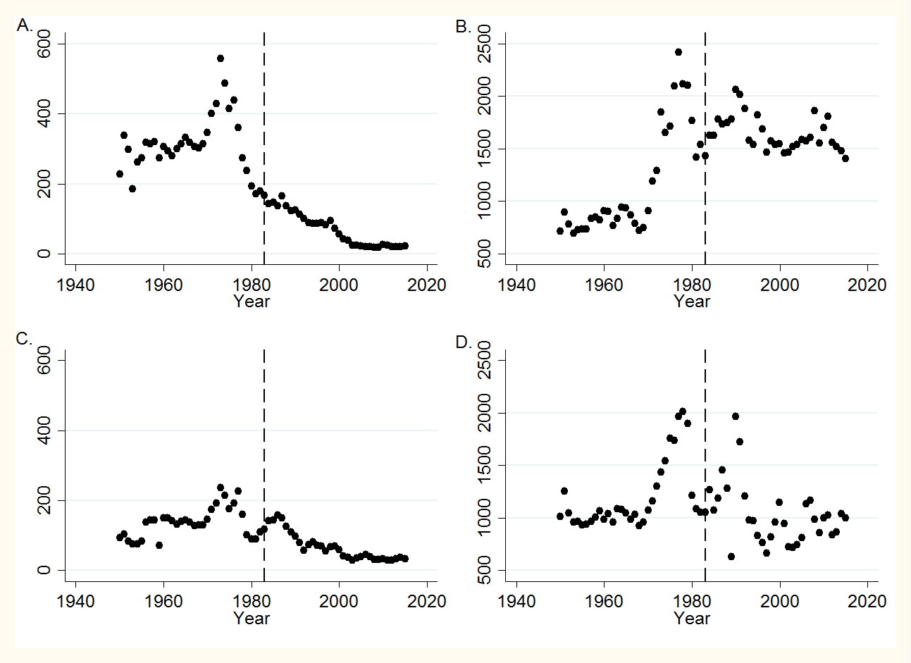

Figure 6 — Value and Average Value of Fish Landings Graphed Over Time

The dashed line in each panel references the year 1983. *Panel A* *(top left)* shows the total value of cod landings by the UK fleet (measured in £ million) from 1950 to 2015. *Panel B (top right)* shows the average value of cod landings by the UK fleet (measured in £ per ton) from 1950 to 2015. *Panel C (bottom left)* shows the total value of haddock landings by the UK fleet (measured in £ million) from 1950 to 2015. *Panel D (bottom right)* shows the average value of haddock landings by the UK fleet (measured in £ per ton) from 1950 to 2015.

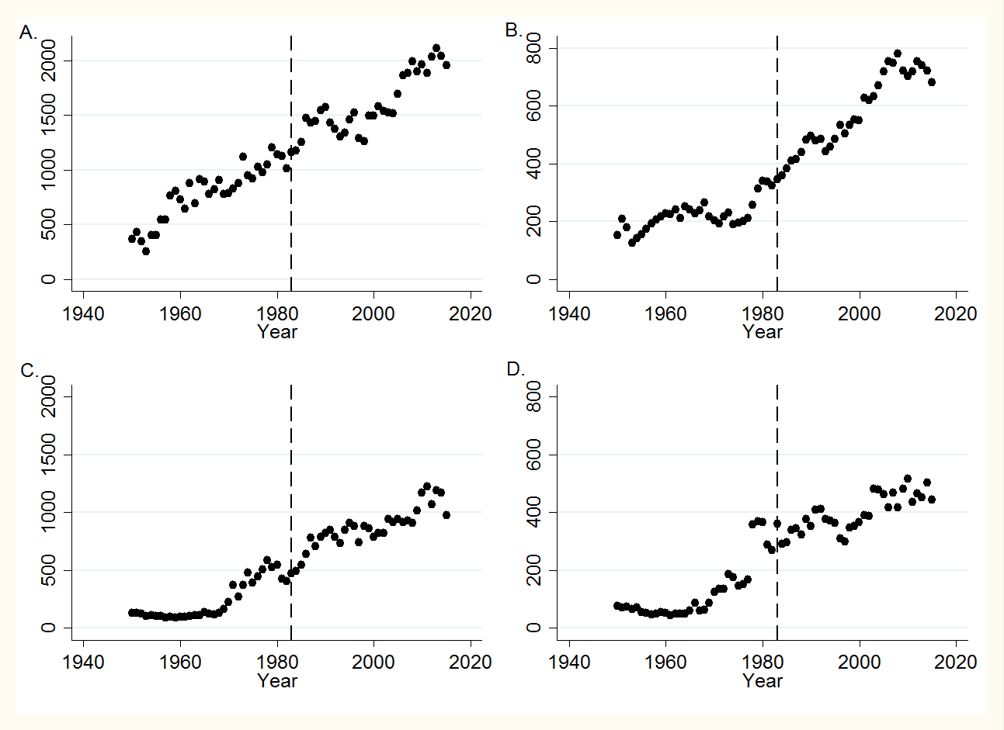

Figure 7 — Value and Quantity of Imports and Exports Graphed Over Time

The dashed line in each panel references the year 1983. *Panel A* *(top left)* shows the total value of fish and fisheries products imports into the UK (measured in £ million) from 1950 to 2015. *Panel B (top right)* shows quantity of fish and fisheries products imports into the UK (measured in thousands of tons) from 1950 to 2015. *Panel C (bottom left)* shows the total value of UK fish and fisheries products exports (measured in £ million) from 1950 to 2015. *Panel D (bottom right)* shows the quantity of UK fish and fisheries products exports (measured in thousands of tons) from 1950 to 2015.

Table 4 — Regression Discontinuity Further Robustness Checks:

Value of UK Landings (£ millions)

|  |  |  |  |  |  |
| --- | --- | --- | --- | --- | --- |
|  | (1) | (2) | (3) | (4) | (5) |
|  |  |  |  |  |  |
|  |  |  |  |  |  |
| 1981 Dummy | -175.62 |  |  |  |  |
|  | (140.74) |  |  |  |  |
| 1982 Dummy |  | -191.61 |  |  |  |
|  |  | (140.27) |  |  |  |
| 1983 Dummy |  |  | -248.10*** |  |  |
|  |  |  | (60.37) |  |  |
| 1984 Dummy |  |  |  | -236.68* |  |
|  |  |  |  | (138.65) |  |
| 1985 Dummy |  |  |  |  | -255.09* |
|  |  |  |  |  | (139.21) |
|  |  |  |  |  |  |
| Observations | 66 | 66 | 66 | 66 | 66 |
| R-squared  Adj R-squared | 0.390  0.350 | 0.393  0.353 | 0.510  0.478 | 0.403  0.364 | 0.407  0.368 |

Standard errors in parentheses

*** p<0.01, ** p<0.05, * p<0.1

Table 5 — Additional RD Model Results:

UK Fleet Size

|  |  |  |  |
| --- | --- | --- | --- |
|  | (1) | (2) | (3) |
|  |  |  |  |
|  |  |  |  |
| 1983 Dummy | 3179.46*** | -60.42 | -331.38 |
|  | (600.22) | (704.58) | (746.12) |
| 1992 Dummy | 934.02 | -1008.30 | 164.51 |
|  | (822.14) | (835.82) | (770.97) |
| 2002 Dummy | -885.98 | 506.94 | 1655.53** |
|  | (916.88) | (809.55) | (710.97) |
| 2013 Dummy | 15.50 | 1744.82** | -729.10 |
|  | (882.43) | (840.10) | (908.72) |
| Observations | 66 | 66 | 66 |
| R-squared  Adj R-squared | 0.511  0.452 | 0.712  0.667 | 0.808  0.769 |

Standard errors in parentheses

*** p<0.01, ** p<0.05, * p<0.1

Table 6 — Additional RD Model Results:

Total and Average Value of Cod Landings

|  |  |  |  |
| --- | --- | --- | --- |
|  | (1) | (2) | (3) |
|  |  |  |  |
| *Panel One: Cod Total Value*  *(£ million)* |  |  |  |
| 1983 Dummy | -173.79*** | -60.24 | 38.08 |
|  | (31.77) | (40.05) | (45.19) |
| 1992 Dummy | -20.39 | -5.45 | -6.18 |
|  | (43.22) | (48.05) | (45.59) |
| 2002 Dummy | -47.91 | -59.49 | -28.05 |
|  | (48.17) | (46.26) | (41.76) |
| 2013 Dummy | 57.61 | 44.93 | 8.70 |
|  | (46.86) | (49.86) | (54.97) |
| Observations  R-squared  Adj R-squared  *Panel Two: Cod Avg Value*  *(£ per ton)*  1983 Dummy | 66  0.854  0.833  -152.43 | 66  0.900  0.882  -593.13*** | 66  0.928  0.912  -536.04** |
|  | (135.12) | (186.02) | (233.73) |
| 1992 Dummy | -257.98 | -440.27** | -282.98 |
|  | (183.85) | (223.17) | (235.80) |
| 2002 Dummy | -213.05 | -80.83 | 75.87 |
|  | (204.90) | (214.84) | (216.03) |
| 2013 Dummy | -144.78 | 26.70 | -333.93 |
|  | (199.31) | (231.54) | (284.33) |
|  |  |  |  |
| Observations | 66 | 66 | 66 |
| R-squared  Adj R-squared | 0.743  0.707 | 0.791  0.752 | 0.814  0.771 |

Standard errors in parentheses

*** p<0.01, ** p<0.05, * p<0.1

Table 7 — Additional RD Model Results:

Total and Average Value of Haddock Landings

|  |  |  |  |
| --- | --- | --- | --- |
|  | (1) | (2) | (3) |
|  |  |  |  |
| *Panel One: Haddock Total Value*  *(£ million)* |  |  |  |
| 1983 Dummy | -30.71* | 28.27 | 55.67** |
|  | (15.66) | (20.01) | (25.40) |
| 1992 Dummy | -32.19 | -17.19 | -16.85 |
|  | (21.31) | (24.00) | (25.63) |
| 2002 Dummy | -13.47 | -24.57 | -15.33 |
|  | (23.75) | (23.02) | (23.48) |
| 2013 Dummy | 34.27 | 20.55 | 9.28 |
|  | (23.09) | (24.90) | (30.90) |
| Observations  R-squared  Adj R-squared  *Panel Two: Haddock Avg Value*  *(£ per ton)*  1983 Dummy | 66  0.760  0.727  -332.68** | 66  0.832  0.801  -510.52** | 66  0.847  0.813  -285.42 |
|  | (137.95) | (207.04) | (260.25) |
| 1992 Dummy | -558.17*** | -620.89** | -546.37** |
|  | (187.69) | (248.39) | (262.55) |
| 2002 Dummy | -366.20* | -320.46 | -181.59 |
|  | (209.19) | (239.12) | (240.54) |
| 2013 Dummy | 0.185 | 58.73 | -188.27 |
|  | (203.48) | (257.71) | (316.59) |
|  |  |  |  |
| Observations | 66 | 66 | 66 |
| R-squared  Adj R-squared | 0.458  0.382 | 0.475  0.379 | 0.533  0.427 |

Standard errors in parentheses

*** p<0.01, ** p<0.05, * p<0.1

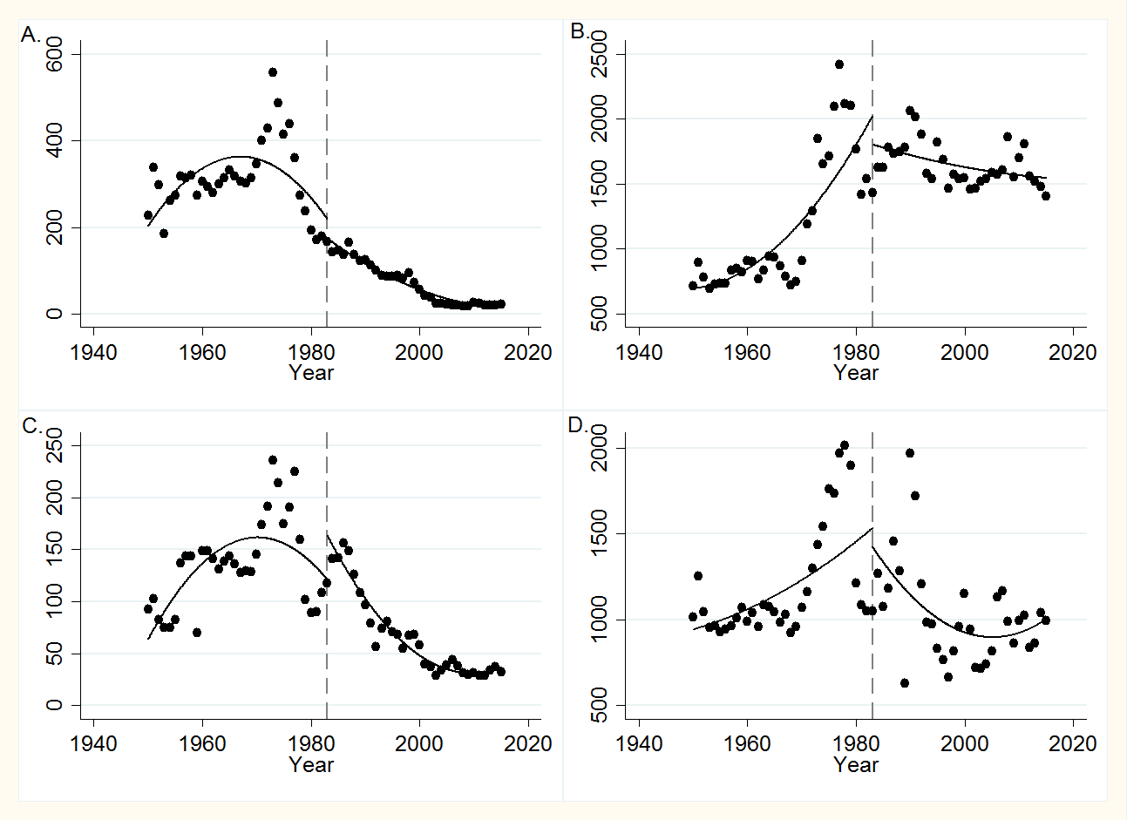

Figure 8 — Regression Discontinuity Panel: Fish Total and Average Value

The dashed line in each panel references the year 1983. *Panel A* *(top left)* shows the RD graph for the total value of cod landings by the UK fleet (measured in £ million) from 1950 to 2015. *Panel B (top right)* shows the RD graph for the average value of cod landings by the UK fleet (measured in £ per ton) from 1950 to 2015. *Panel C (bottom left)* shows the RD graph for the total value of haddock landings by the UK fleet (measured £ million) from 1950 to 2015. *Panel D (bottom right)* shows the RD graph for the average value of haddock landings by the UK fleet (measured in £ per ton) from 1950 to 2015.

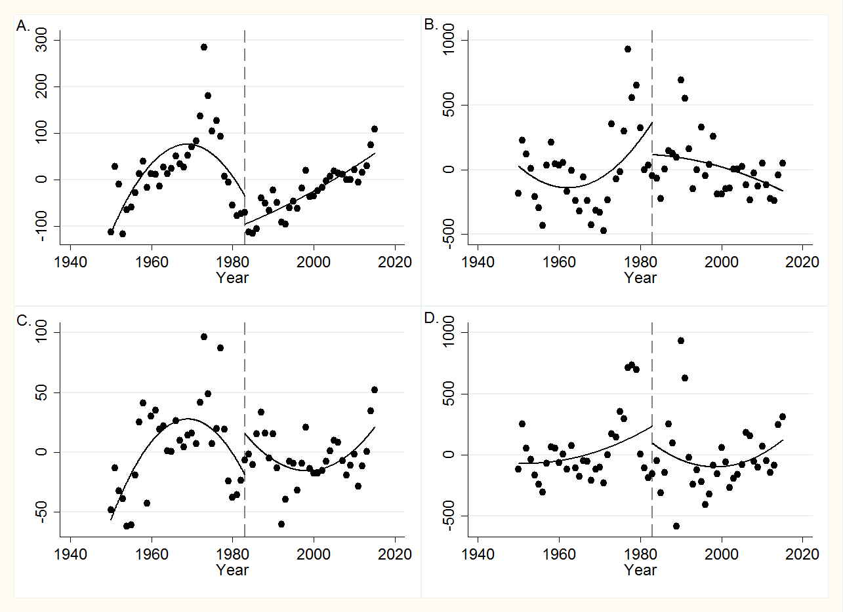

Figure 9 — Regression Discontinuity Panel: Fish Value Residuals

The dashed line in each panel references the year 1983. *Panel A* *(top left)* plots the residuals for a regression of the total value of cod landings by the UK fleet on GDP and sea surface temperature variation (SSTV) from 1950 to 2015. *Panel B (top right)* plots the residuals for a regression of the average value of cod landings by the UK fleet on GDP and SSTV from 1950 to 2015. *Panel C (bottom left)* plots the residuals for a regression of the total value of haddock landings by the UK fleet on GDP and SSTV from 1950 to 2015. *Panel D (bottom right)* plots the residuals for a regression of the average value of haddock landings by the UK fleet on GDP and SSTV from 1950 to 2015.

Table 8 — Additional RD Model Results:

Value and Quantity of Imports

|  |  |  |  |
| --- | --- | --- | --- |
|  | (1) | (2) | (3) |
|  |  |  |  |
| *Panel One: Value of Imports*  *(£ million)* |  |  |  |
| 1983 Dummy | 43.65 | 147.74* | -16.62 |
|  | (58.41) | (85.05) | (107.65) |
| 1992 Dummy | -347.27*** | -342.16*** | -257.79** |
|  | (79.48) | (102.04) | (108.60) |
| 2002 Dummy | -27.53 | -32.11 | -11.68 |
|  | (88.58) | (98.23) | (99.49) |
| 2013 Dummy | -29.45 | -32.64 | -151.11 |
|  | (86.16) | (105.86) | (130.96) |
| Observations  R-squared  Adj R-squared  *Panel Two: Quantity of Imports*  *(thousands of tons)*  1983 Dummy | 66  0.959  0.953  72.89*** | 66  0.962  0.955  47.74* | 66  0.966  0.958  -10.16 |
|  | (17.83) | (26.78) | (31.68) |
| 1992 Dummy | -41.43* | -55.94* | -54.47* |
|  | (24.26) | (32.13) | (231.96) |
| 2002 Dummy | 29.54 | 39.97 | 22.37 |
|  | (27.04) | (30.93) | (29.28) |
| 2013 Dummy | -93.95*** | -80.12** | -61.02 |
|  | (26.31) | (33.33) | (38.54) |
|  |  |  |  |
| Observations | 66 | 66 | 66 |
| R-squared  Adj R-squared | 0.978  0.975 | 0.979  0.975 | 0.983  0.979 |

Standard errors in parentheses

*** p<0.01, ** p<0.05, * p<0.1

Table 9 — Additional RD Model Results:

Value and Quantity of Exports

|  |  |  |  |
| --- | --- | --- | --- |
|  | (1) | (2) | (3) |
|  |  |  |  |
| *Panel One: Value of Exports*  *(£ million)* |  |  |  |
| 1983 Dummy | 100.98** | -134.65** | -78.44 |
|  | (48.19) | (59.14) | (70.79) |
| 1992 Dummy | -87.35 | -231.15*** | -183.41** |
|  | (65.57) | (70.95) | (71.43) |
| 2002 Dummy | -87.02 | 16.21 | 76.45 |
|  | (73.08) | (68.30) | (65.43) |
| 2013 Dummy | -41.45 | 95.80 | -28.59 |
|  | (71.09) | (73.62) | (86.13) |
| Observations  R-squared  Adj R-squared  *Panel Two: Quantity of Exports*  *(thousands of tons)*  1983 Dummy | 66  0.949  0.942  67.76** | 66  0.967  0.961  -43.81 | 66  0.973  0.967  -53.09 |
|  | (28.61) | (31.41) | (41.26) |
| 1992 Dummy | -9.12 | -3.76 | 15.34 |
|  | (38.92) | (37.68) | (41.63) |
| 2002 Dummy | 63.81 | 61.10* | 74.85* |
|  | (43.48) | (36.27) | (38.14) |
| 2013 Dummy | -7.35 | -14.59 | -52.17 |
|  | (42.19) | (39.09) | (50.19) |
|  |  |  |  |
| Observations | 66 | 66 | 66 |
| R-squared  Adj R-squared | 0.909  0.897 | 0.952  0.944 | 0.954  0.944 |

Standard errors in parentheses

*** p<0.01, ** p<0.05, * p<0.1

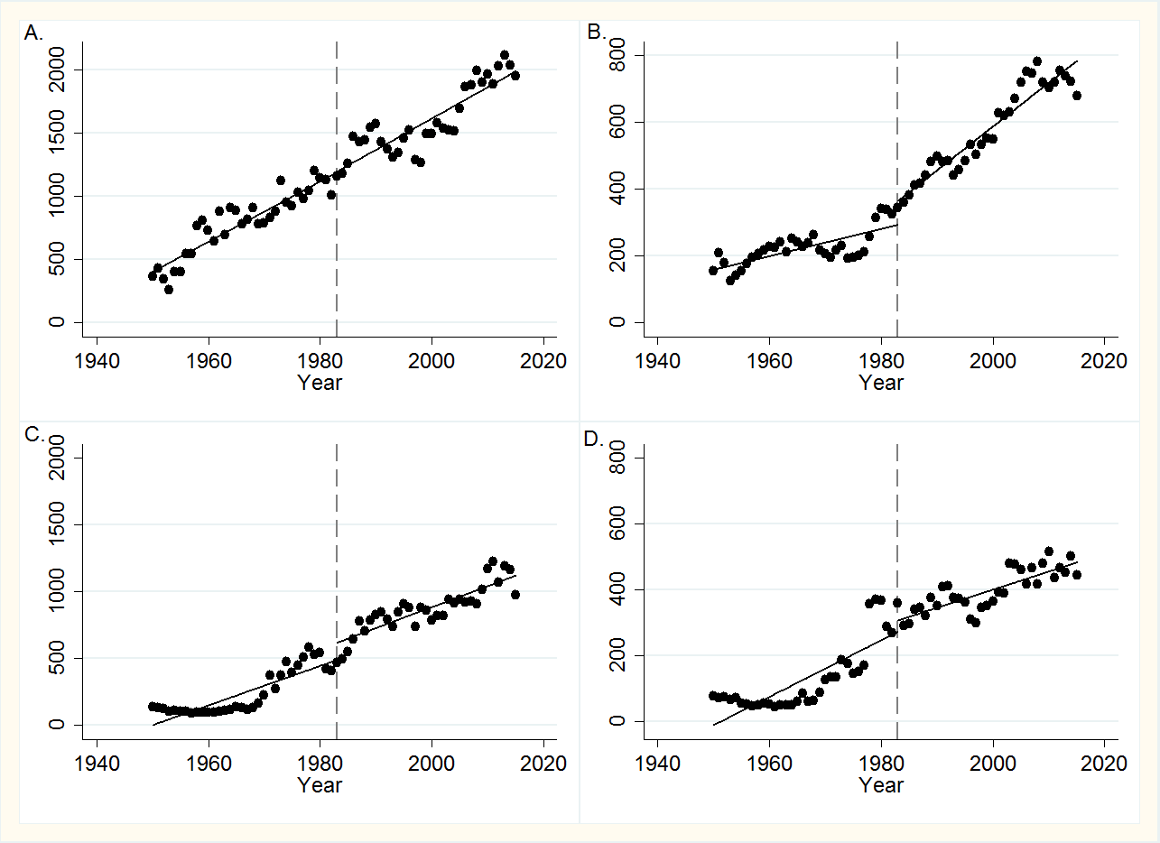

Figure 10 — Regression Discontinuity Panel: Trade

The dashed line in each panel references the year 1983. *Panel A* *(top left)* shows the RD graph for the total value of fish and fisheries products imports into the UK (measured in £ million) from 1950 to 2015. *Panel B (top right)* shows the RD graph for the quantity of fish and fisheries products imports into the UK (measured in £ per ton) from 1950 to 2015. *Panel C (bottom left)* shows the RD graph for the total value of UK fish and fisheries products exports (measured £ million) from 1950 to 2015. *Panel D (bottom right)* shows the RD graph for the quantity of UK fish and fisheries products exports (measured in £ per ton) from 1950 to 2015.

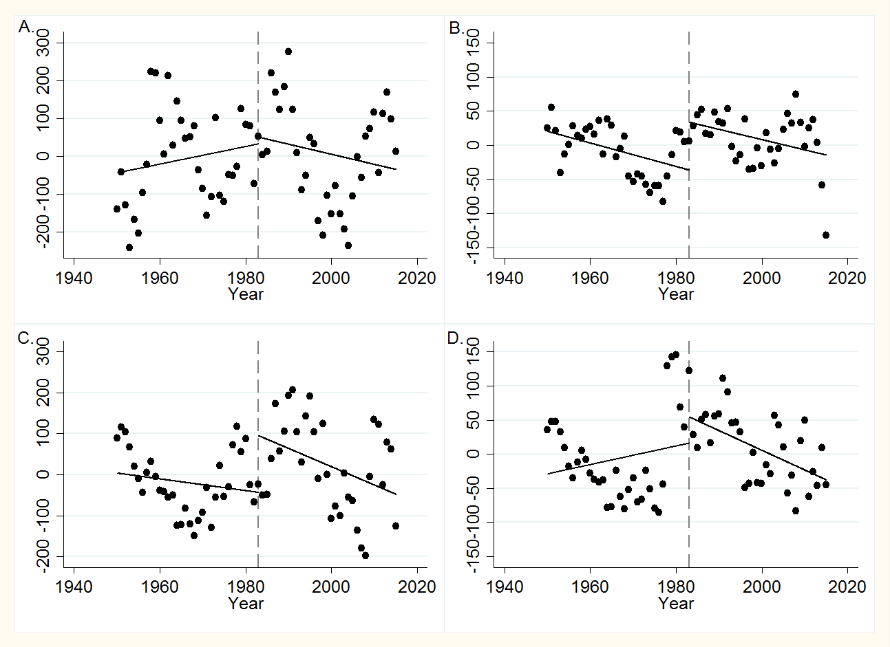

Figure 11 — Regression Discontinuity Panel: Trade Residuals

The dashed line in each panel references the year 1983. *Panel A* *(top left)* plots the residuals for a regression of the total value of fish and fisheries products imports into the UK on GDP and sea surface temperature variation (SSTV) from 1950 to 2015. *Panel B (top right)* plots the residuals for a regression of the quantity of fish and fisheries products imports into the UK on GDP and SSTV from 1950 to 2015. *Panel C (bottom left)* plots the residuals for a regression of the total value of UK fish and fisheries products exports on GDP and SSTV from 1950 to 2015. *Panel D (bottom right)* plots the residuals for a regression of the quantity of UK fish and fisheries products exports on GDP and SSTV from 1950 to 2015.

References

Abernathy, K. E., P. Trebilcock, B. Kebede, E. H. Allison, and N. K. Dulvy. 2010. Fuelling the decline in UK fishing communities? ICES Journal of Marine Science, 67: 1076-85.

Abila, Richard O., Konstantine O. Odongkara, and Paul O. Onyango 2009. Macro-economic assessment of Lake Victoria fishing industry in East Africa. Technical Report: 1-8.

Akpalu, Wisdom. 2009. Economics of Biodiversity and Sustainable Fisheries Management. Ecological Economics, 68: 2729-33.

Al-Fattal, Rouba. 2009. The tragedy of the commons: Institutions and fisheries management at the local and EU levels. Review of Political Economy, 21(4): 537-47.

Amundsen, Eirik S., Trond Bjorndal, and Jon M. Conrad. 1995. Open Access Harvesting of the Northeast Atlantic Minke Whale. Environmental and Resource Economics, 6: 167-85.

Arnason, Ragnar, Leif K. Sandal, Stein Ivar Steinshamn, and Niels Vestergaard. 2005. Actual Versus Optimal Fisheries Policies: An Evaluation of the Cod Fishing Policies of Denmark, Iceland and Norway. Working Paper. University of Southern Denmark.

Bailey, Michael. 2016. Chapter 11: Regression Discontinuity: Looking for Jumps in Data. In: Real Econometrics*.* 1st ed., 365-390. Oxford, UK: Oxford University Press.

British Sea Fishing Co. Common Fisheries Policy (CFP). In British Sea Fishing.co.uk [database online]. 2016.

Carpenter, Griffin. 2016. The impact of the EU Common Fisheries Policy on UK fisheries. London: The New Economics Foundation.

Castillo-Manzano, Jose I., Lourdes Lo pes-Valpuesta, Fernando Gonzalez-Laxe, and Diego J. Pedregal. 2014. An econometric analysis of the Spanish fresh fish market. ICES Journal of Marine Science, 71(3): 628-35.

Chan, Szu Ping. 2016. What the UK's fishing industry wants from Brexit. *The Telegraph.* 2016.

Charles, Anthony T. 1998. Living With Uncertainty in Fisheries: Analytical Methods, Management Priorities and the Canadian Groundfish Experience. Fisheries Research, 37: 37-50.

Crutchfield, Stephen R. 1985. An econometric model of the market for New England groundfish. Northeastern Journal of Agricultural and Resource Economics, 14: 128-43.

Daw, Tim, and Tim Gray. 2005. Fisheries science and sustainability in international policy: A study of failure in the European Union's Common Fisheries Policy. *Marine Policy* 29: 189-97.

Dewees, Christopher M. 1998. Effects of Individual Quota Systems on New Zealand and British Columbia Fisheries. Ecological Applications, 8 (1): S133-8.

Engelkamp, Stephan, and Doris Fuchs. 2015. Performing ‘Green Europe’? A Narrative Analysis of European Fisheries Policy. Working Paper. University of Muenster.

EU House of Lords. 2008.  The progress of the Common Fisheries Policy. London: Authority of the House of Lords, 21.

European Commission. Discarding and the landing obligation. in European Commission Fisheries [database online]. Brussels, 2016.

European Commission. 2016. Fisheries: Norway. In: European Union [database online]. Brussels.

European Union. 2016. The New Common Fisheries Policy: Sustainability in Depth. In: European Union [database online]. Brussels.

Eustice, George. 2016. The Fishing Industry and Brexit. Cornwall, UK.

Eythorsson, Einar. 2000. A Decade of ITQ-Management in Icelandic Fisheries: Consolidation Without Consensus. Marine Policy, 24: 483-92.

Finch, Ray. 2015. Stolen Seas: How the UK Suffers Under the Common Fisheries Policy. London: Europe of Freedom and Direct Democracy.

Freitas, Carla., Esben Moland Olsen, Even Moland, Lorenzo Ciannelli, and Halvor Knutsen. 2015. Behavioral Responses of Atlantic Cod to Sea Temperature Changes. Ecology and Evolution, 5 (10): 2070-2083.

Gauvin, John R., John M. Ward, and Edward E. Burgess. 1994. Description and Evaluation of the Wreckfish P*polyprion Americanus*) Fishery Under Individual Transferable Quotas. Marine Resource Economics, 9: 99-118.

Grieve, Chris. 2001. Reviewing the Common Fisheries Policy: EU Fisheries Management for the 21st Century. London: Institute for European Environmental Policy.

Hatcher, Aaron, and Daniel Gordon. 2005. Further investigations into the factors affecting compliance with U.K. fishing quotas. Land Economics, 81 (1): 71-86.

Hirst, David, and Oliver Bennett. 2017. *Brexit: What next for UK fisheries?* London: UK Parliament House of Commons Library, CBP7669.

Horan, Richard D., and James S. Shortle. 1999. Optimal Management of Multiple Renewable Resource Stocks: An Application to Minke Whales. Environmental and Resource Economics, 13 (4): 435-58.

Jin, Di, Eric Thunberg, Hauke Kite-Powell, and Kevin Blake. 2002. Total Factor Productivity Change in the New England Groundfish Fishery: 1964-1993. Journal of Environmental Economics and Management, 44: 540-56.

Jones, Miranda C., Stephen R. Dye, John K. Pinnegar, Rachel Warren, and William W. L. Cheung. 2015. Using scenarios to project the changing profitability of fisheries under climate change. Fish and Fisheries, 16: 603-22.

Marine Management Organisation. 2016. UK Sea Fisheries Annual Statistics. [Database Online]. London.

McWhinnie, Stephanie F. 2009. The Tragedy of the Commons in International Fisheries: An Emplirical Examination. Journal of Environmental Economics and Management, 57: 321-33.

Met Office Hadley Center. 2016. Northern Hemisphere Sea Surface Temperature Variation. [Database Online]. London.

Newell, Richard G., James N. Sanchirico, and Suzi Kerr. 2002. Fishing Quota Markets.Washington, D.C.: Resources for the Future, 02-20.

Neilsen, Max., Ola Flaaten, and Staffan Waldo. 2012. Management of and economics returns from selected fisheries in the Nordic countries. Marine Resource Economics, 27: 65-88.

Office for National Statistics. 2016. Gross Domestic Product: Chained Volume Measures: Seasonally Adjusted  £. London.

Peirson, G., D. Tingley, J. Spurgeon, and A. Radford. 2001. Economic Evaluation of Inland Fisheries in England and Wales. Fisheries Management and Ecology, 8: 415-24.

Raakjær, Jesper, and Troels Jacob Hegland. 2012. Introduction: Regionalising the Common Fisheries Policy. Maritime Studies, 11(5): 1-8.

Smit, Wil. 1997. Common Fishery Policy and National Fisheries Management. Marine Resource Economics, 12: 355-9.

Stavins, Robert N. 2010. "The Problem of the Commons: Still Unsettled After 100 Years" Harvard Kennedy School Faculty Research Working Paper.

Sumaila, Ussif Rashid, Gordon R. Munro, and Jon G. Sutinen. 2007. Recent Developments in Fisheries Economics: An Introduction. Land Economics, 83 (1): 1-5.

Surís-Regueiro, Juan C., Manuel M. Varela-Lafuente, and Carlos Iglesias-Malvido. 2003. Effectiveness of the structural fisheries policy in the European union. Marine Policy, 27(6): 535-44.

The UK in a Changing Europe. 2016. British Fishermen Want Out of the EU — Here's Why. In: The UK in a Changing Europe [database online].

Thurstan, Ruth H., Simon Brockington, and Callum M. Roberts. 2010. The effects of 118 years of industrial fishing on UK bottom trawl fisheries. *Nature Communications*: 1-6.

Tietenberg, Tom. 2006. Chapter 13: Renewable Common-Pool Resources: Fisheries and Other Species. In: Environmental and Natural Resource Economics*.* 7th ed., 286-315. New York: Pearson Education, Inc.

Villasante, Sebastian., Graham J. Pierce, Cristina Pita, Cesar Pazos Guimerans, Joao Garcia Rodrigues, Manel Antelo, Jose Maria Da Rocha, Javier Garcia Cutrin, Lee C. Hastie, Pedro Veiga, U. Rashid Sumaila, and Marta Coll. 2016. Fishers' perceptions about the EU discards policy and its economic impact on small-scale fisheries in Galicia (North West Spain). Ecological Economics, 130: 130-8.

Walmsley, Suzannah. 2016. Brexit: Where next for UK fisheries? ABP Marine Environmental Research.

Walter, Tiffany. 2010.  The EU’s common fisheries policy: A review and assessment. Miami-Florida European Union Center of Excellence, 7.

1. There is not any single correct way to choose the functional form for an RD model, and I examined several measures to determine the accuracy of my specification choice. Examining AIC and BIC did not change my decision to choose the quadratic functional form. I also tried narrowing my dataset and thus the bandwidth that the RD model operates in. I tested several year ranges, but none had any significant affect or altered my decision to choose the quadratic functional form. Higher powers over-fit my data, and the quadratic functional form seems to be the most accurate given the data.
2. This table provides results for my economic econometric model that includes the reform dummies. When this model is run without the reform dummies, the effect of the CFP policy implementation in 1983 is -176.3, statistically significant at the 5 percent level.
3. Note that the 2002 reform coefficient was right at the cut-off, very close to being not statistically significant at the 10 percent level.
4. When specification (2) is run without the reform dummies, the effect on cod landings of the CFP policy implementation in 1983 is 48.52 thousands of tons, statistically significant at the 5 percent level.
5. When specification (2) is run without the reform dummies, the effect on haddock landings of the CFP policy implementation in 1983 is 51.62 thousands of tons, statistically significant at the 5 percent level.