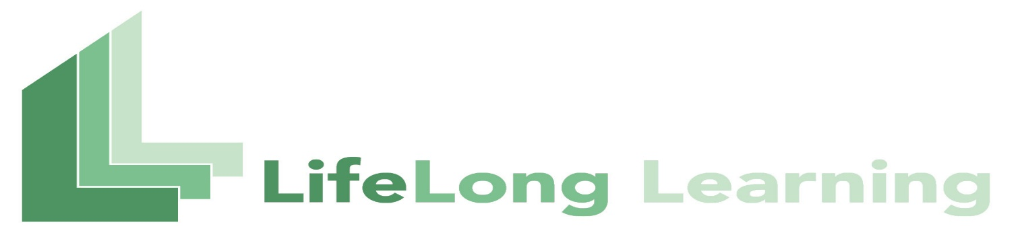
APPLICATION FOR MEMBERSHIP
Membership in the LifeLong Learning Program is open to all adults who have an interest in the pursuit of knowledge – no formal education is required. New members should complete both sides of this form and see instructions below.
□ Individual Application □ Gift |  | □ Family Application
Personal Information
Full Name(s):
Address:
City, State, Zip:
Home Phone:
Cell Phone:
Email Address(es):
Please note: Your email address will be used ONLY to provide information about programming and opportunities offered through the LifeLong Learning Program. If you prefer not to receive emails from LLP, please check here:
Emergency
Contact:
Phone:
Membership Dues
Individual annual dues for the LifeLong Learning Program are $40.00 and family dues are $70.00 for individuals living in the same household.
Membership scholarships are available. Please check here if you would like a scholarship.
Individual LifeLong Learning Program Dues . . . . . . . . . . . . . . . . . . . . . . . . . . . . . . . . . . . $40.00
Family LifeLong Learning Program Dues . . . . . . . . . . . . . . . . . . . . . . . . . . . . . . . . . . . . . . $70.00
TOTAL . . . . . . . . . . . . . . . . . . . . . . . . . . . . . . . . . . . . . . . . . . . . . . . . . . . . . . . . . . . . . . . . . ______
Please make checks payable to: LifeLong Learning Program and mail to:
LifeLong Learning Program
Upstate Institue
Colgate University
13 Oak Drive
Hamilton, NY 13346

